Chapter: 10 (Halo alkanes and Haloarene)
- One Mark Questions:
- Give IUPAC name of the following organic compound:

CH₃-CH=C- CH-CH₃

CH₃ Br

- Write the structural formulae of 4-Chloropent-2-ene.

Q3.Arrange the following halides in order of increasing SN² reactivity CH₃Cl,CH3Br,CH₃CH₂Cl, (CH₃)₂CHCl
Q5.What is the order of reactivity of different alkyl halides in nucleophilic substitution reaction? Q4.An alkyl halide C₄H₉Cl is optically active. What is its structure?
Q7.Which type of solvents aregenerally used to carry out SN¹ reaction? Q8.Identify the chiral and achiral molecules in following pair of compounds? A:CH₃CHCH₂CH₃ B :CH₃CH₂CH₂CH₂Br

Q9.Give two uses of iodoform (CHI₃)?

Q10.Write a chemical reaction in which iodide ion displaces diazonium group from a diazonium salt? Q11.How you will convert 2-Bromopropane to 1-bromopropane?
Q12.In following pairs of halogen compound which compound undergoes faster SN¹ reaction?
- Cl Cl iii) Cl iv)

  - ii) B)

Q13.How you will convert aniline into cholobenzene? Cl Q14.Name the iodine containing hormone, the deficiency of which causes goiter?
Q15.Name the synthetic halogen compound which is used in treatment of malaria? Q16.Which isomer of C₄H₉Br will have lowest boiling point?
Q17.Write the IUPAC name of DDT?

Q18.Why sulphuric acid is not used during reaction of alcohol with KI? Q19.Out of CH₃Br and CH₃Cl which will have higher boiling point and why? Q20.Which one of following has highest dipole moment?
(i) CH₂Cl₂ (ii) CHCl₃ (iii) CCl₄

Two marks questions:
Q1.Define the following terms:

- Ambidient nucleophile (ii) Chirality Q2.Write short note on sandmeyer reaction? Q3.Write the structures of main products: (i).Chlorination of benzene in presence of UV light.
(ii).Propene is treated with HBr in presence of benzoyl peroxide. Q4.Complete the following reactions:

(i).C₆H₅N₂Cl +KI ?

- CH₂=CH₂ +Br₂ CCl₄ ?

Q5.Explain why haloarenes are much less reactive than haloalkanes towards nucleophilic substitution reaction?
Q6.Write short note on:

(i).Wurtz reaction (ii).Wurtz-Fittig reaction. Q7.How you will convert:
(i).Ethyl chloride into ethyl alcohol. (ii).Ethyl chloride to ethane
Q8.Alkyl halides are insoluble in water though they contain polar C-X bond? Q9.Give one test to distinguish between:
(i).Chloroform and carbontetrachloride (ii).Methanol and ethanol.
Q10.Write short note on :

(i).Finkelstein reaction (ii).Hundsdiecker reaction

Three Marks Questions:
- Explain why:

(a).Dipole moment of cholorobenzene is lower than cyclohexyl chloride. (b).Grignard reagent should be prepared under anhydrous conditions? (c).Chloroform is stored in dark Brown bottles?
Q2.What happens when:

(a).Chloroform is heated with silver power. (b).Ethyl chloride treated with alcoholic KOH (c).Alcohol reacts with thionyl chloride?
Q3.How you will conert:

(a).Chlorobenzene into toluene (b).Chlorobenzene to phenol (c).Ethyl bromide to diethyl ether. Q4.Complete the following reactions:
(a).CHCl₃ +CH₃COCH₃ ?

(b).CH₃CH₂CH₂Br +KOH(alc.) ? (c).CHCl₃ +HNO₃ Heat ?
Q5.Give the chemical test to distinguish between following pair of compounds:

  - Cl and Cl

  - Ethyl chloride and ethyl bromide

  - Chlorobenzene and benyl chloride

Q6.Give reasons:

(i).Boiling point of alkyl bromide is higher than alkyl chloride. (ii).Alkyl halides are better solvents than aryl halides.
(iii).Haloalkanesare used as solvent in industry are choloro compounds rather than bromo compounds. Q7.Answer the following:
(i).What effect should the following resonance of vinyl chloride has on its dipole moment.

CH₂=CH-Cl ⁻CH₂—CH=Cl⁺→
(ii).Iodoform is obtained by the reactions of acetone with hypoiodite but not with iodide ion.

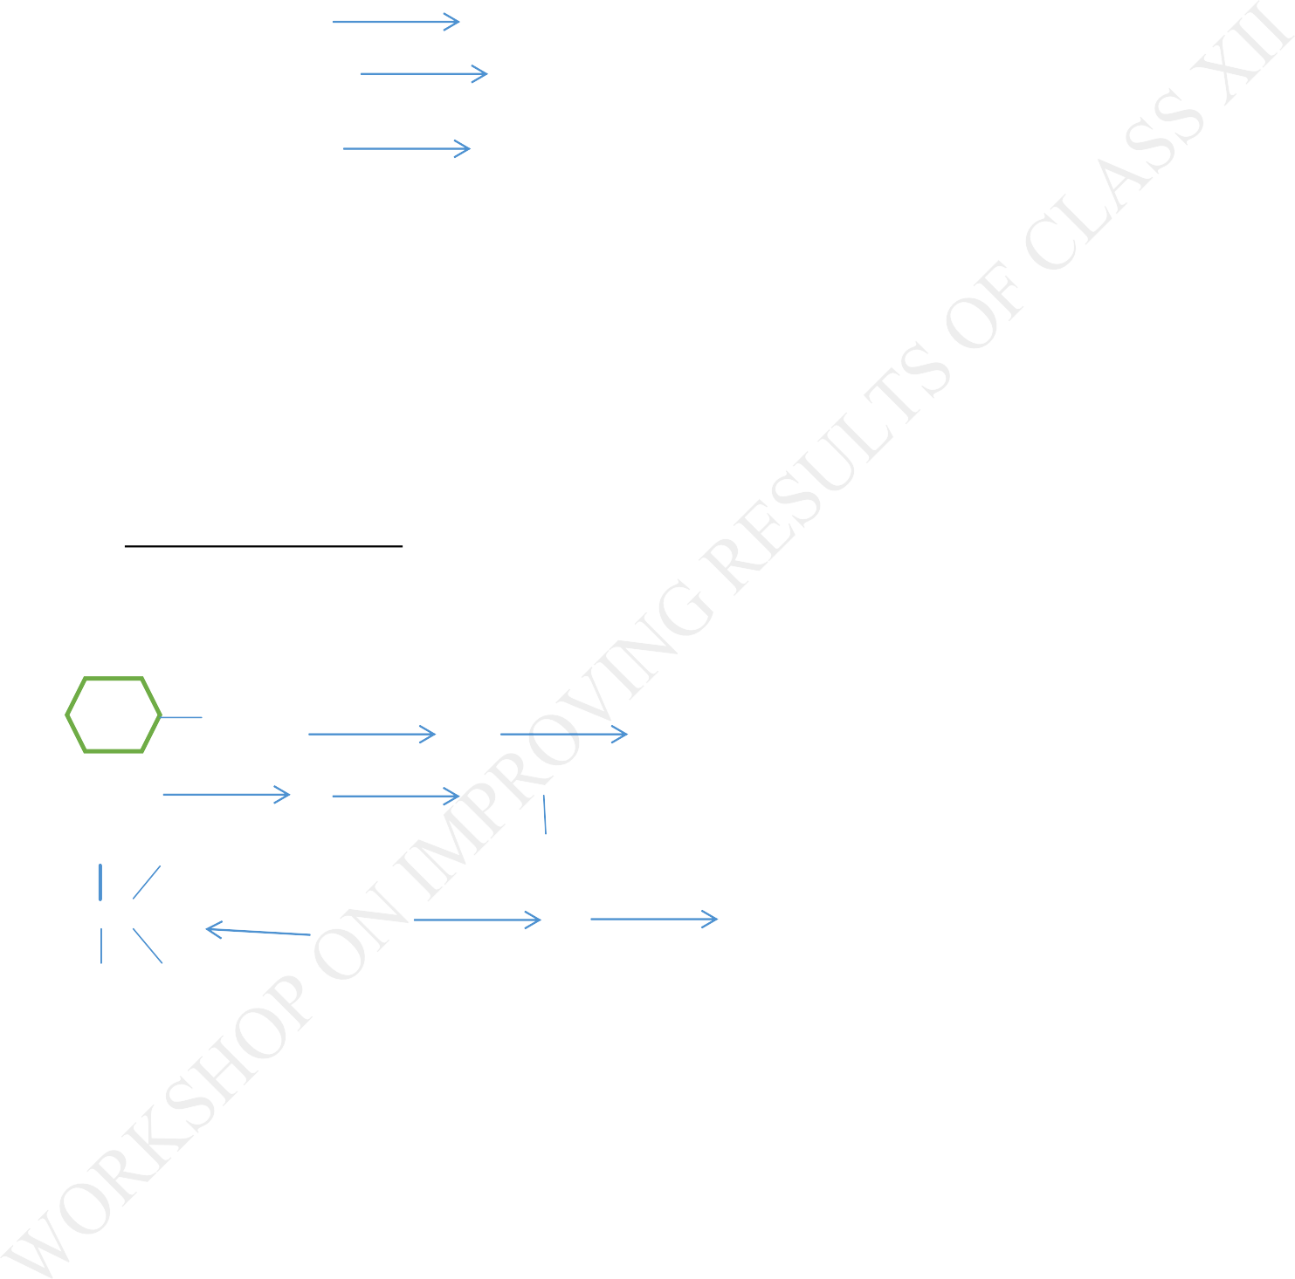

(iii).Vinyl chloride is hydrolysed more slowly than ethyl chloride.

Q8.Write the structure of major organic product in each of following reactions: (i).CH₃-CH₂-CH₂-Cl +NaI Acetone
(ii).CH₃-CH₂-CH₂OH +SOCl₂

(iii).CH₃CH₂CH=CH₂ +HBr Peroxide Q9.Give uses of following:
    - CCl4
    - DDT
    - Choloroform

Q10.Distinguish between SN1 and SN2 reactions?

Five Marks Question

- Identify A,B,C,D,E,R,R’ in the following:

Br +Mg dry ether A H2O B

R-Br+Mg dry ether C D2O CH3CHCH3 CH3 CH3 D
CH₃-C-C-CH3 Na/ether R’-X Mg D H2O E CH3 CH3
- What happens when:

(a).n-butyl chloride is treated with alcoholic KOH (b).Bromonenzene is teated with Mg in presence of dry ether (c).ethyl chloride is treated with aquous KOH
(d).Ethyl bromide is Na in presence of dry ether. (e).Methyl chloride is treated with KCN

Q3.Primary alkyl halide A C₄H₉Br reacted with alcoholic KOH give compound B.Compound B is reacted with HBr to give C which ia an isomer of A.When A was reacted with Na metal it give a compound (D) C₈H₁₈ that was different than the compound when n-butyl bromide reacted with sodium .Give the strural formulae for A and write the equations for all the reactions?
Q4.Write short note on:

(i).Fittig reaction (ii).Friedal Craft Alkylation (iii).Friedal Craft Acylation (iv).Gatterman reaction (v).Carbylaaminereation Q5.Give reasons:
(i).Benzyl chloride undergoes SN1 reactions faster than cyclohexy methyl chloride. (ii).p-Dichlorobenzene has higher melting point than ortho-dichlorobenzene.
(iii).Out of chlorobenzene and choloromethane ,which is more reactive towards nucleophilic substitution reaction?
- Thionyl chloride is preffered for preparing alkyl chlorides from alcohols. (V).Iodide ion is a better nucleophile than bromide ion?
Answer key
  - One Mark Question: 1.Ans:4-Bromo-3-methylpent-2-ene. 2.Ans:CH₃-CH=CH-CH₂-CH₃
Cl

- Ans:( CH₃)₂CHCl<CH₃CH₂Cl,CH₃Cl<CH₃Br

- Ans: H

CH₃- C*-CH₂-CH₃

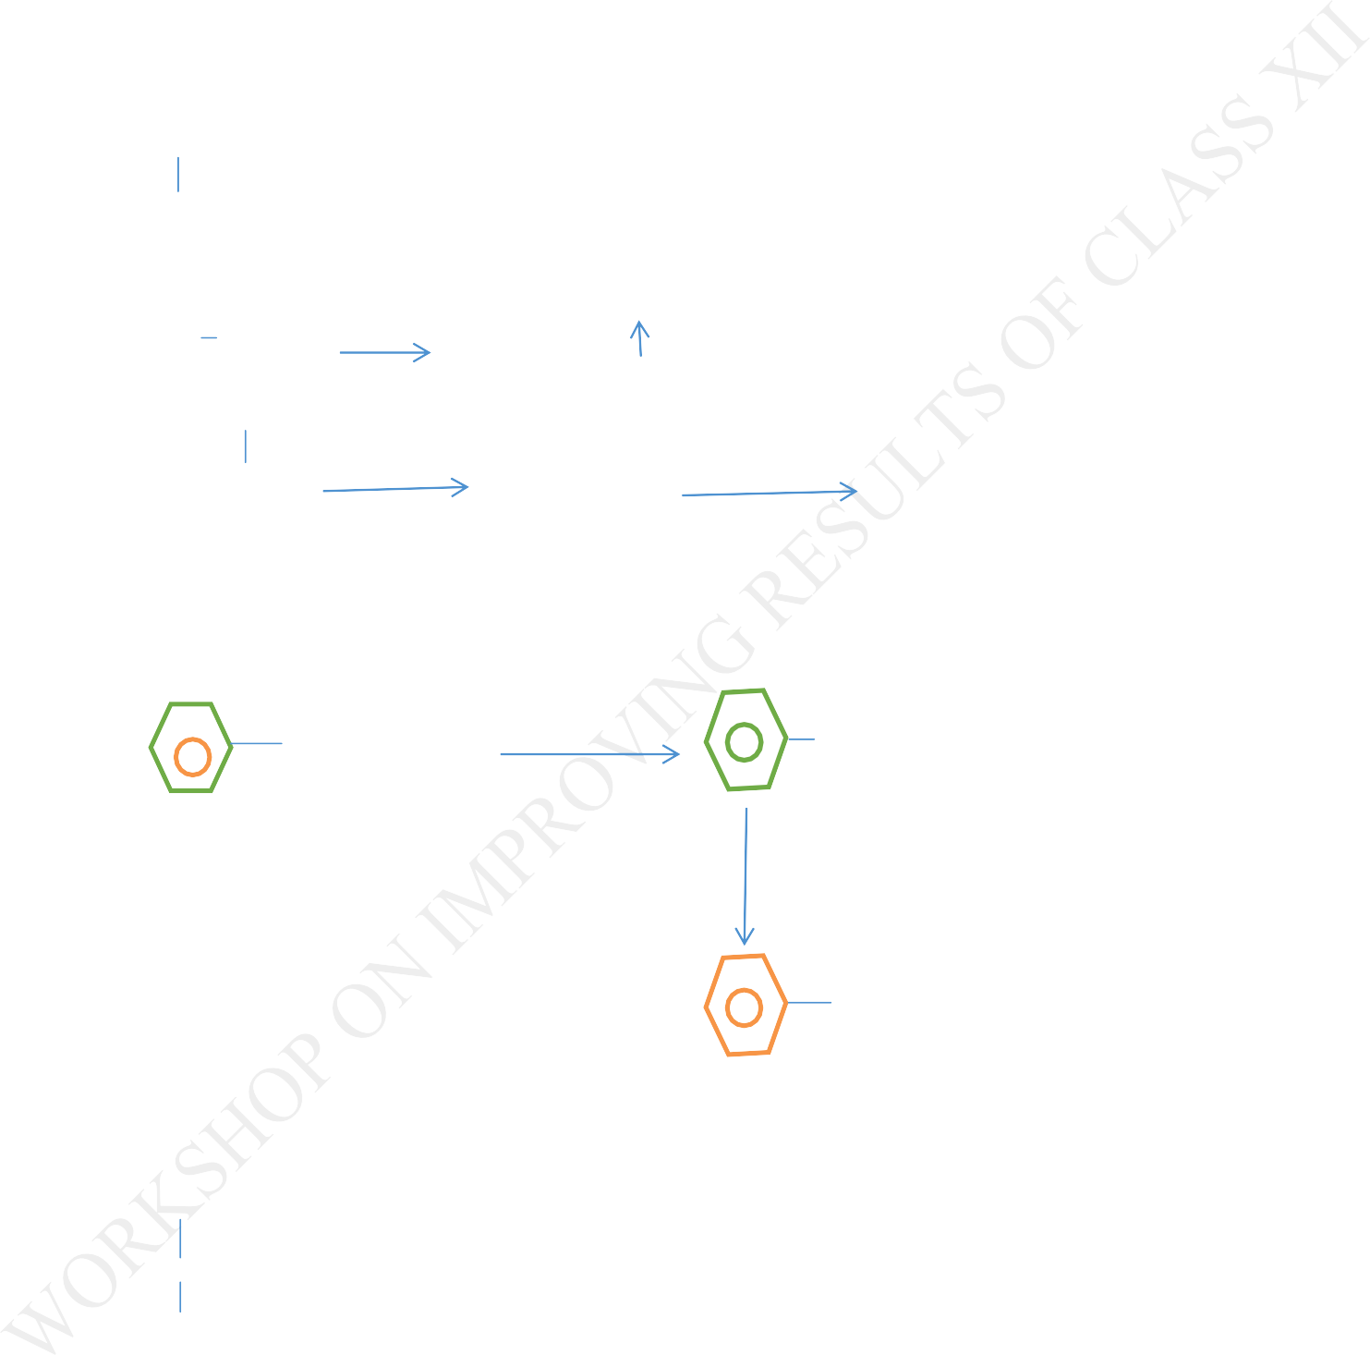
Cl 5.Ans.RI>RBr>RCl
- Ans:No

- Ans: Polar protic solvents. 8.Ans: CH₃CHCH₂CH₃
Br

9.Ans: 1.As antiseptic 2.As photosensitizer in emulsion of AgBr to make photographic film. 10.Ans: C₆H₅-N⁺ Cl⁻ +KI C H I +KCl +N
2 6 5 2
- Ans: Br

CH₃-CH-CH₃ (Alc.KOH) CH₃-CH=CH₂HBr/Peroxide CH₃-CH₂-CH₂Br

- Ans:A (i) B (iii) 13.Ans:

NH₂ +HNO₂ +HCl NaNO₂ +HCl N₂⁺Cl⁻ +H₂0

CuCl/HCl

Cl +N₂

14.Ans.Thyroxine 15.Ans:Chloroquine. 16.Ans: CH₃
CH₃-C-Br :tert-Butyl bromide CH₃
17.Ans:2-(1,1-Dicholoro diphenyl)-1,1,1-tricholoroethane. 18.Ans:Because it first converts KI to HI and then oxidises it to I₂.

- Ans:CH₃Br.More the molecular mass, more the boiling point. 20.Ans:CH₂Cl₂

Two marks questions:
1.(i)Ans:The nucleophiles having two nucleophiliccentres.For example Cyanide group.

-C N :C=N-

ii).An object which is not superimposable on its mirror image is said to be chiral.The property of being chiral is known as chirality.
2.Ans:NaNO₂ +HCl 273-278K NaCl +HNO₂

-NH₂ +HNO₂ +HCl 273-278K N₂⁺Cl⁻ +2H₂O

C₆H₅N₂+Cl- CuCl/HCl C₆H₅Cl+N₂

3.Ans: i) ClCl

+3Cl₂U.V.Light

Cl Cl

Cl Cl

ii).CH₃-CH=CH₂ +HBr Peroxide CH₃-CH₂-CH₂-Br 4.Ans : i) C₆H₅N₂Cl +KI C₆H₅I +KCl +N _{2(g)}
(ii).CH₂=CH₂ +Br₂ CCl₄ CH₂BrCH₂Br

- Ans:1.Due to resonace C-Cl bond aquires double bond charcter .

ii.Inhaloarenes Carbon bearing halogen is sp2 hybirdised.So C-X bond is shorter and stronger.

- Ans.(i) RX +2Na +X-R Dry Ether R-R +2NaX

(ii).R-X +2Na + X Dry ether R + 2NaX. 7.Ans (i).C₂H₅Cl +KOH (aq) C₂H₅OH +KCl

(ii).C₂H₅Cl +2[H] Zn-Cu/C₂H₅OH C₂H₆ +HCl

- Ans:Because haloalkanes cannot form hydrogen bond with water molecules and at the same time they cannot break the hydrogen bonds present in water molecule.
- Ans: (a). Chloroform when heated with aniline and alc.KOH offensive smeel of isocyanide is produced.

C₆H₅NH₂ +CHCl₃ +3KOH (alc.) heat C₆H₅NC +3KCl +3H₂O

(b).By iodoform test

In case of methanol no yellow ppt.But in case of ethanol yellow ppt are formed. CH₃CH₂OH +4NaOI NaOH +I₂ CHI₃+HCOONa +NaI+H₂O
CH₃OH +NaOI NaOH+I₂ No yellow ppt 10.Ans.
- CH₃-CH₂-Cl +NaI Acetone CH₃-CH₂-I +NaCl (b). RCOOAg +Br₂ CCl₄,350K R-Br+AgBr+CO_{2(g)}

Three Marks question:
1.Ans. (a).Electronegativity of carbon is less than Chlorine so slight negative charge develops on chlorine atom and positive charge on carbon atom.Lower dipole moment of cholobenzene is due to (i) Resonace (ii).different hybirdisation states of C- atom
(b).Grignard reagent are very reactive.These are readily decomposed by compounds containing acidic hydrogen as follows
RMgX + H₂O RH +Mg(OH)X

(c).Because it reacts with oxygen in prsesnce of sunlight to form phosgene gas. CHCl₃ + ½ O₂ Sunlight COCl₂ +HCl
2Ans.

(a).CHCl₃ +6Ag +CHC_{l3} 6AgCl +CH≡CH

(b).C₂H₅Cl +KOH (alc) CH₂=CH₂ +H₂O +KCl

(c).R-OH +SOCl₂ R-Cl+HCl+SO₂

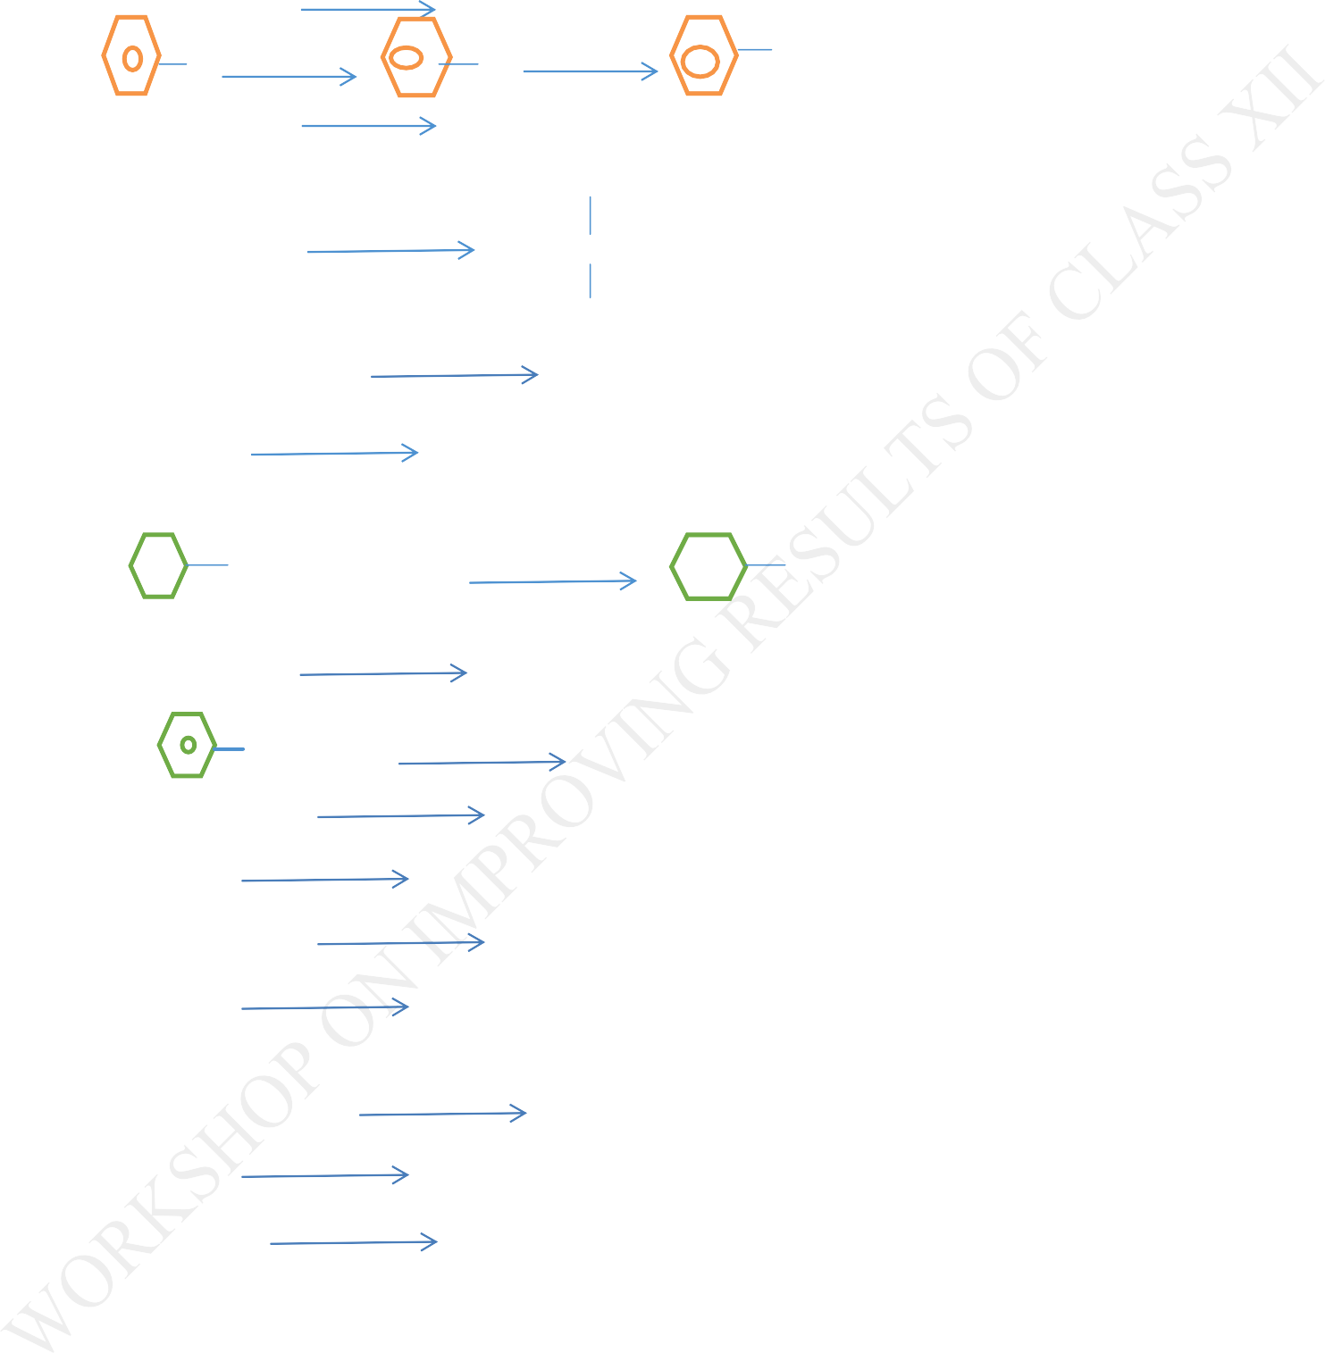

3Ans.How you will conert:

(a).C₆H₅Cl +2Na+Ch₃Cl dry ether C₆H₅CH₃ +2NaCl

- Cl NaOH,623K ONa H₂O/H+ OH (c).2C₂H₅Br+Ag₂O(dry) C₂H₅-O-C₂H₅ +2AgBr Ans4.OH
(a).CHCl₃ +CH₃COCH₃ CH₃-C-CH₃ CH₃
(b).CH₃CH₂CH₂Br +KOH(alc.) CH₃-CH=CH₂ +KBr +H₂O (c).CHCl₃ +HNO₃ Heat Cl₃C-NO₂ +H₂O
Ans5.Give the chemical test to distinguish between following pair of compounds:

I) Cl +KOH(ag)+ OH ⁻ +KCl

KCl+AgNO₃ AgCl (White ppt)+KNO₃

Cl +KOH(ag) No Reaction

  - C₂H₅Cl+KOH(aq) C₂H₅OH +KCl

KCl+AgNO₃ AgCl (White ppt)+KNO₃ (soluble in NH4OH) C₂H₅Br+KOH(aq) C₂H₅OH +KBr
KBr+AgNO₃ AgBr (pale yellow ppt)+KNO₃ ( partially soluble in NH₄OH)

iii) C₆H₅CH₂Cl +KOH(aq) C₆H₅CH₂OH +KCl

KCl+AgNO ₃ AgCl (White ppt)+KNO₃ (soluble in NH₄OH) C6H5Cl+KOH(aq) No reaction
Ans6.Give reasons:

(i).Beacuse of higher magnitude of Vander Waal’s forces in alkyl bromide than alkyl halide. (ii).Due to greater polarity of alkyl halides.

(iii).C-Cl bond is more polar than C-Br bond. So a better solvent than alkyl bromide. Ans7.Answer the following:
    - CH₂=CH-Cl⁻ CH₂—CH=Cl⁺
It will decrease the dipole moment of vinyl chloride relative to ethyl chloride.

(ii).To prepare Iodoform from acetone I⁺ is required. As I⁺ can only be supplied IO⁻ not by I⁻,therefore hypoiodite is used to convert acetone into iodoform.
(iii).Due to resonace there is double bond character between Carbon and chlorine. Ans8.
(i).CH₃-CH₂-CH₂-Cl +NaI Acetone CH₃-CH2-CH₂-I +NaCl (ii).CH₃-CH₂-CH₂OH +SOCl₂ CH₃-CH₂-CH₂Cl +SO₂ +HCl (iii).CH₃CH₂CH=CH₂ +HBr Peroxide CH₃-CH₂-CH₂-CH₂Br
Ans.9.Give uses of following:

- CCl₄:Used as solvent.
- DDT:Used as insecticide
- Chloroform:Used as anesthesia in surgery. Ans10.Distinguish between SN¹ and SN² reactions?

Five Marks Question
Ans 1.

A= MgBr: B= : C=RMgBr R=CH₃CHCH₃ R’=C(CH₃)₃: D=C(CH₃)₃MgX
E=HC(CH₃)₃

Ans2.What happens when:

(a).CH₃-CH₂-CH₂-CH₂-Cl +KOH (alc) CH₃-CH₂-CH=CH₂ +KCl +H₂O

(b).C₆H₅Br +Mg dry ether C₆H₅MgBr

(c).C₂H₅Cl+KOH(aq) C₂H₅OH+KCl (d).2C₂H₅Br+2Na dry ether CH₃-CH₂-CH₂-CH₃ +2NaBr (e).CH₃Cl +KCN(alc) CH₃CN +HCl
Ans 3.A) CH₃-CH(CH₃)-CH₂Br 1-Bromo-2-methylpropane.

- CH₃-C(CH₃)=CH₂ 2-Methylprop-1-ene.

- CH₃-C(CH₃)(Br)-CH₃ 2-Bromo-2-methylpropane

- CH₃-CH(CH₃)-CH₂-CH₂-CH(CH₃)-CH₃ 2,5-Dimethylhexane Equations for reaction:
A alc.KOH B

B+HBr C

2A+2Na D +2NaBr

4.Ans.

i).C₆H₅Cl +2Na +C₆H5Cl C₆H₅-C₆H₅ + 2Nacl (ii).C₆H₆ +CH₃Cl (Anhyd)AlCl₃C₆H₅CH₃ +HCl
iii).C₆H₅Cl +CH₃COCl Anhyd AlCl₃C₆H₅ COCH₃
- C₆H₅N₂Cl Cu/HCl C₆H₅Cl +N₂
- CH₃CH₂NH₂ +CHCl₃ +KOH(alc.) CH₃CH₂NC +3KCl+3H₂O A ns: 5.
(i).Because in case of benzyl chloride the carbocation is formed after the loss of Cl⁻ stabilized by resonance.
(ii).It is due to symmetry of p-Dichlorobenzene which fits in crystal lattice better than ortho- dichlorobenzene.
(iii).Chloromethane is more reactive being an alkyl halide

(iv). Thebyproducts of the reaction i.e.SO₂ and HCl being gases escape into the atmosphere leaving behind the alkyl chloride in almost pure state.
(V).Because of bigger size and lower electronegativity.

